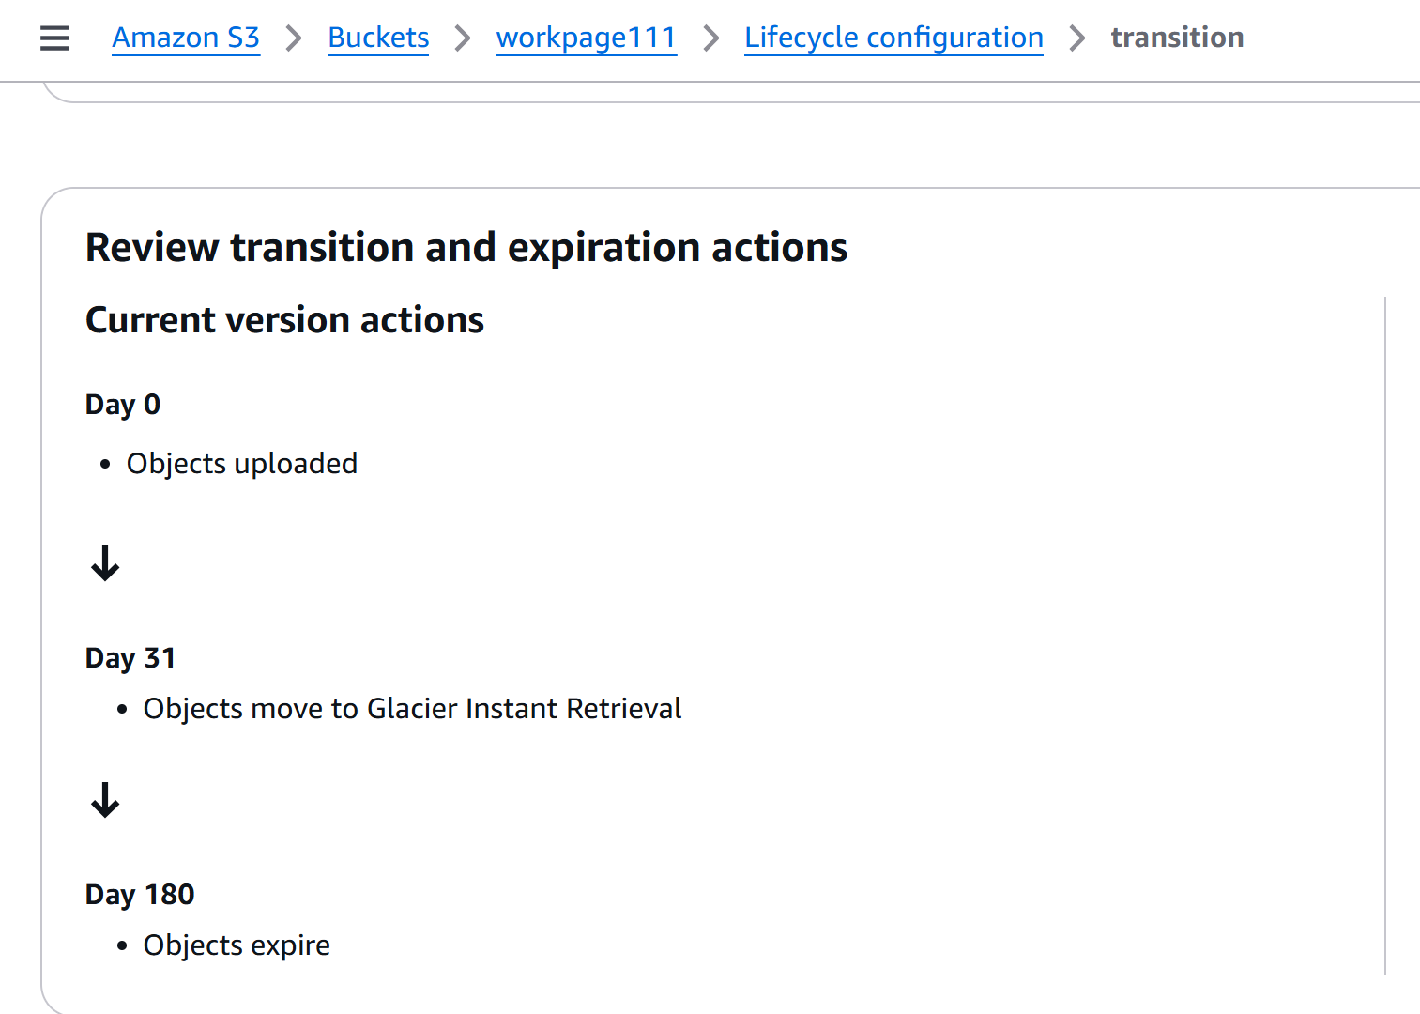

The screen shot of my bucket policy shows that after 0 to 30 days of uploading files into my s3 bucket, files are moved to Glacier instant retrieval.

Object expire: indicate the number of days awazon will automatically delete objects that have been uploaded into the bucket for a specific number of days which in my case is 180 days